## Findigs

Scoping start date: Oct 13, 2023

Implementation Completed Date (Go live date): May 10, 2024

MSA Signature Date: Feb 15, 2024

GTM POC: Skoro

Implementation POC: Royce

ERP: QBO

Tax Integration: No Tax

### 

### Key people at Merchant

### Head of Finance: [Sebastian Hart](https://www.linkedin.com/in/sebastian-a-hart/)

* + Primary PoC and Decision Maker

### Finance Associate: [Ellie Barney](https://www.linkedin.com/in/ellie-barney-1787a5236/)

* + We’re replacing the manual work she used to have to do
* Engineering: Parth

### Company summary

“Findigs makes renting safe and easy for renters and property managers. Rent units faster with zero fraud. Our digital underwriting platform verifies every applicant’s identity and income in minutes, no matter how they earn money. Fast, secure rental applications. Seamless screening and decision-making. This is renting, redesigned.”  
  
AM Notes

Sebastian and Ellie are really friendly and we’re working with them to build out a Remittance workflow entirely from scratch.

### Billing model

* Info on how merchant bills - **Monthly, usage based billing**
* How contract is broken up - **No contracts provided by the client. Tabs to upload generic contract (Sample) as it’s a prerequisite to generating billing terms/events.**

### Contract Processing Steps

1. Steps to process or specifics processing things merchant has requested that may differ from contract (e.g. always back-date invoice date to final day of the month)
   1. None provided from client, use sample tabs contract for processing
   2. Usage processing only (cc: [Azmat Aziz](mailto:aaziz@tabsplatform.com))

### Remittance Setup & End to End Flow (Part of Findigs end of month flow)

1. **What we’ve build for Findigs**
   1. MVP: [Findigs Remittance Build with Orum (Remittance partner)](https://www.notion.so/tabs-platform/Remittances-16e705fc8a694517b0162e50e50c1e64)
   2. V2: [UXR: Remittance v2](https://docs.google.com/document/d/1SrVjESlnWMiNVgLdutv-Z4AT-kvXSTv-tWzQkKjOC-E/edit#heading=h.vrexapqk5hq)
2. **Remittance Setup**
   1. **Collect Bank acct information or survey from portfolio manager**
      1. Survey Monkey [link here](https://www.surveymonkey.com/summary/xPop546vHv9mqyl1y5HxOPdO9EK1Og3_2BN70_2BT2aKCGk_3D?ut_source=lihp)
      2. [Findigs PM responses](https://docs.google.com/spreadsheets/d/1d4M4L_3k-Nj73pZxkdm3cqsl6fAmAH6u41i2_8l7xPA/edit#gid=1577799711)
   2. **“Contract processing”**
      1. Add a new contract (any template is fine)
      2. Assign customer. If none, follow steps below
         1. Create customer
            1. Find the vendor ID
            2. Capture email address and physical address
   3. **Share the spreadsheet with Hyung. Hyung will flip customer to Vendor**
   4. **Orum Setup required** 
      1. This can be done via Garage superpower (ping [Hyung Seok Choi](mailto:hyung@tabs.inc) or [Royce Kok](mailto:rkok@tabsplatform.com) as needed)
      2. 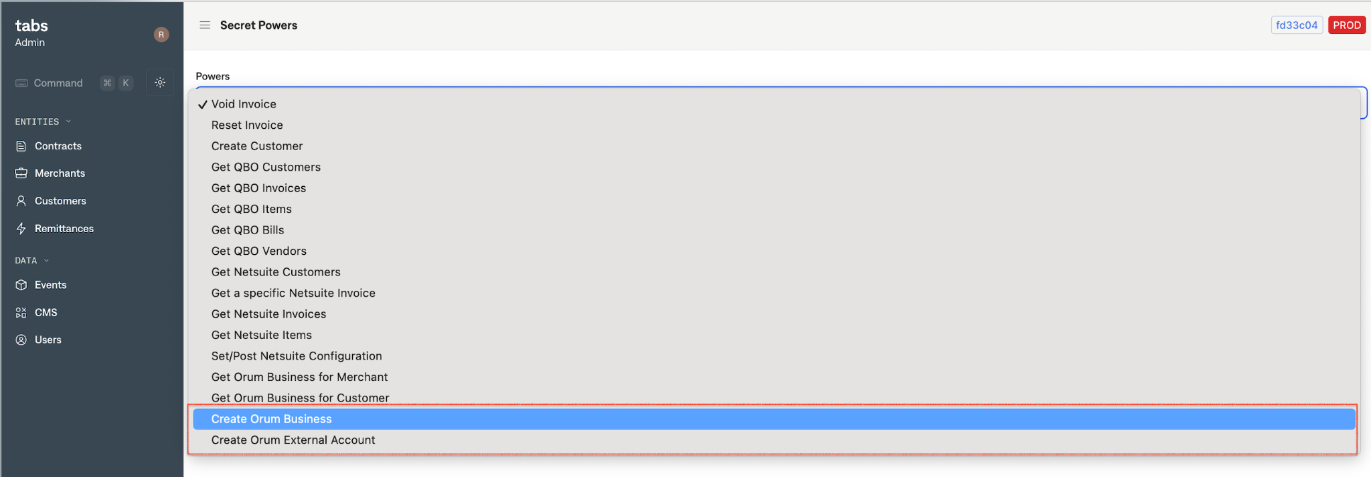
      3. The two super power needed are “**Create Orum Business**” and “**Create Orum External Account**”
         1. JSON for Create Orum External Account

{

"refId":"f013812a-0d82-4c63-9087-ee89e9dcc71a",

"refIdType":"CUSTOMER",

"accountConfig":{

"accountNumber":"00000",

"routingNumber":"00000",

"accountHolderName":"Coastal Group Inc (Truist Bank)"

}

}

* 1. **Log onto** [**Orum to confirm**](https://orum-prod.us.auth0.com/u/login?state=hKFo2SAtM3NpQ1o3YW5seTJsTUF5Nl9zV0hwQVNTLXdxLUlDVqFur3VuaXZlcnNhbC1sb2dpbqN0aWTZIHQzNkdFVWpLM1RBeDUxLXZBWk9LWmZKTjRId1I2Y1VZo2NpZNkgWnQ4N0g5N3pLa1gzTjhYTUpnRFdSS1A1VTVtd0c2OFo)
     1. The business is created
     2. The bank account info is accurate

1. **Remittance ongoing process**
   1. Tabs Team to generate individual remittance (there’s approx 200/ month)
   2. Ellie approves from Findigs (Tabs Platform)
   3. Tabs approves it from Garage before sending over to Orum - [link here](https://garage.tabsplatform.com/prod/remittances)
      1. Fires off the first emails & PDF
      2. **Email Title: New Remittance xxx from Findigs for $xx on [Date]**
   4. Orum process these transfers (approx 4 days) - link [here](https://orum-prod.us.auth0.com/u/login?state=hKFo2SAtM3NpQ1o3YW5seTJsTUF5Nl9zV0hwQVNTLXdxLUlDVqFur3VuaXZlcnNhbC1sb2dpbqN0aWTZIHQzNkdFVWpLM1RBeDUxLXZBWk9LWmZKTjRId1I2Y1VZo2NpZNkgWnQ4N0g5N3pLa1gzTjhYTUpnRFdSS1A1VTVtd0c2OFo)
      1. Observe the status change from “Pending” → “Completed”
   5. Tabs clicks send to QBO on Garage - [link here](https://garage.tabsplatform.com/prod/remittances)
      1. Fires off the second email & PDF
      2. Sends to QBO
      3. **Email Title: Payment confirmation for Remittance xx from Findigs for $XX**

### Events Processing (Part of Findigs end of month flow)

* Monthly (in arrears) events based processing
* Example of usage file shared last month
  + [Findigs Usage Data - April](https://docs.google.com/spreadsheets/d/1-jd2ma8HyUVRFj1GryNSSTiTQn1BVtJNfQ57pbULK8Y/edit#gid=0) - Note: It’s broken down by Property Manager in each row
  + Steps to calculate or confirm remittance amount
    - Deepak pipeline creates 1 off billing terms for findings
    - Royce / Ops team to confirm the remittance amount are accurate
      * Combine QBO Vendor ID and calculate the total amount to be remitted (column name: **total_remittance_to_portfolio, column AH**)
* Note: We’ve processed 4-5 events for them in the month of May, Okay to push back next month if needed.

### Customer Information

* Any important information on specifics customers of this merchant
  + There’s time where Ellie will need to update or change the remittance amount ($$), that’s fine, you can ask Deepak to update the amount.

### Feature Requests

* FR 1
  + What is it
  + Why it's important
  + Urgency

### Rewatch Calls

* Rewatch by dates